ASSIGNMENT – 5.5

HT.NO: 2303A510F9
BATCH: 30

TASK 1: Transparency in Algorithm Optimization
PROMPT:
Generate Python code for two prime-checking methods and
explain how the optimized version improves performance.
CODE:
1.NAIVE APPROACH:
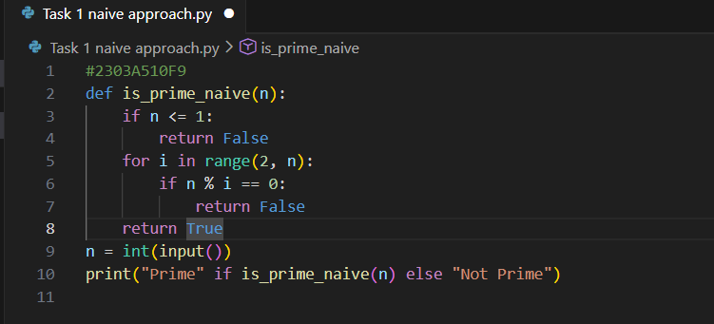

OUTPUT:
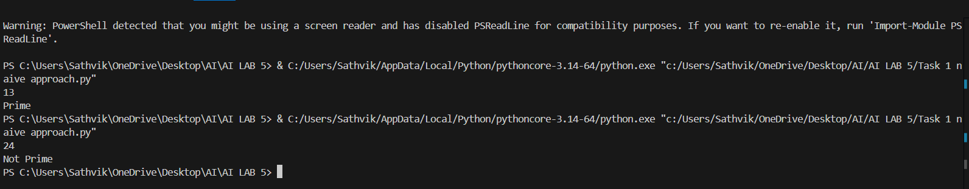

2.OPTIMIZED APPROACH:
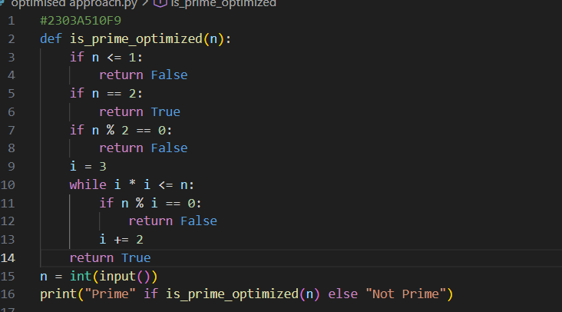

OUTPUT:
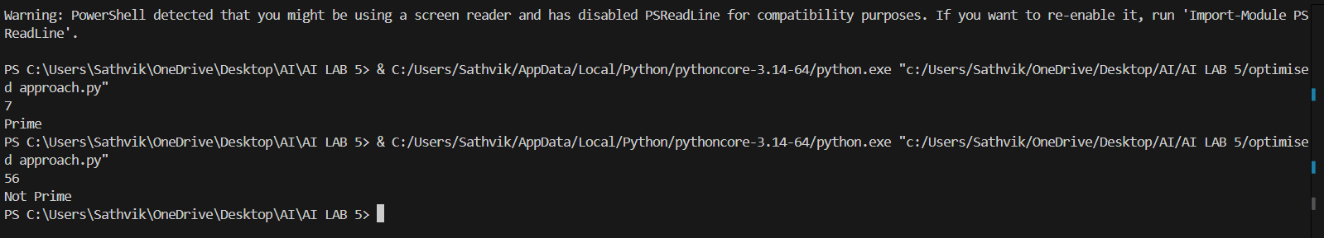

OBSERVATION:
Naive Method:
Checks divisibility from 2 to n-1, so it takes more time for big numbers.
Optimized Method:
Checks only up to √n and skips even numbers, so it is faster and more efficient.

TASK 2: Transparency in Recursive Algorithms
PROMPT:
Generate a Python code to find Fibonacci number using recursion. Take input n and print the result.
CODE:
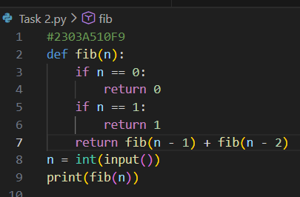

OUTPUT:
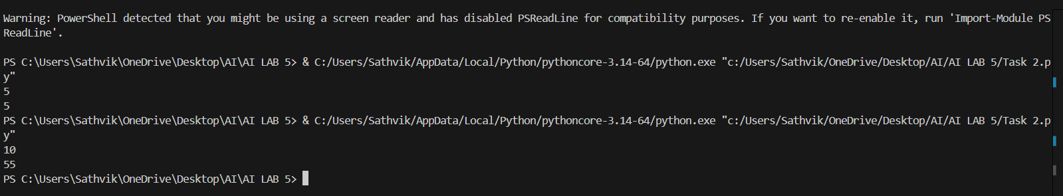

OBSERVATION:
The recursive function breaks the problem into smaller parts and solves them step by step until it reaches a stopping point, after which the final result is obtained.

TASK 3: Transparency in Error Handling
PROMPT:
Generate code with proper error handling and clear explanations
for each exception.
CODE:
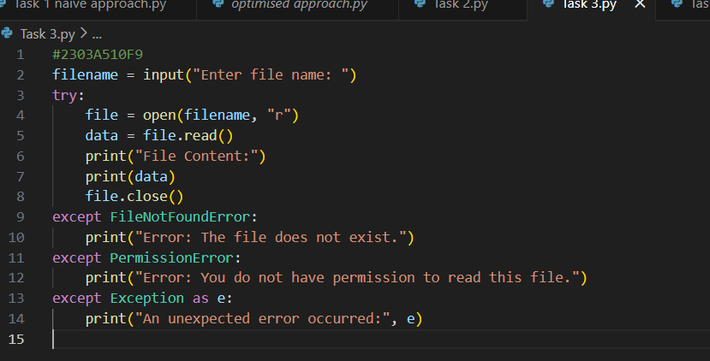

OUTPUT:
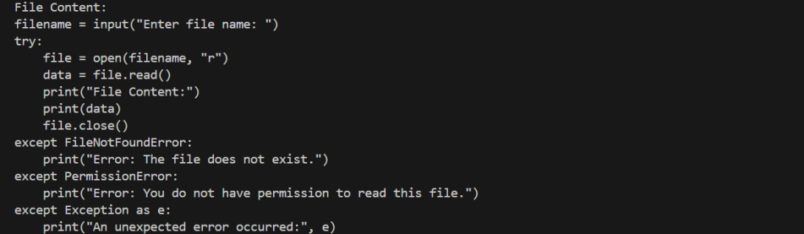

OBSERVATION:
The program safely reads the file and clearly reports errors when the file is missing or inaccessible, instead of stopping unexpectedly.

TASK 4: security in user authentication
PROMPT:
Generate a simple Python-based login system.
CODE:
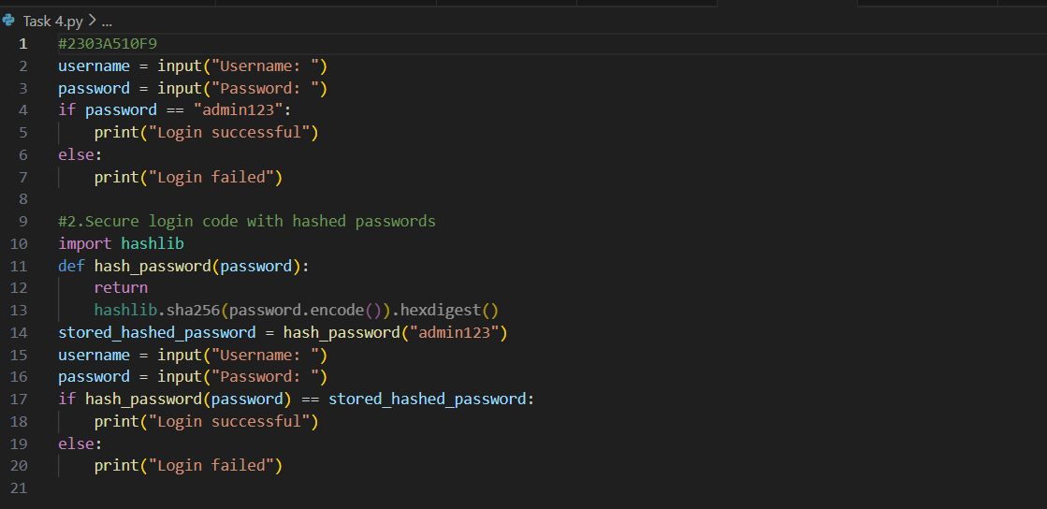
OUTPUT:
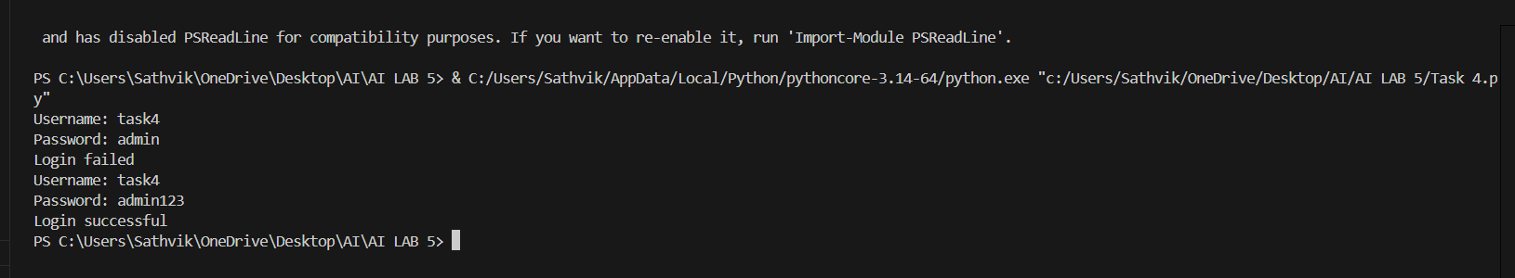
OBSERVATION:
The first code is insecure because it uses plain-text passwords, while the second code improves security by using password hashing.

TASK 5: Privacy in Data Logging
PROMPT:
Generate a Python script that logs user activity including username, IP address, and timestamp.
CODE:
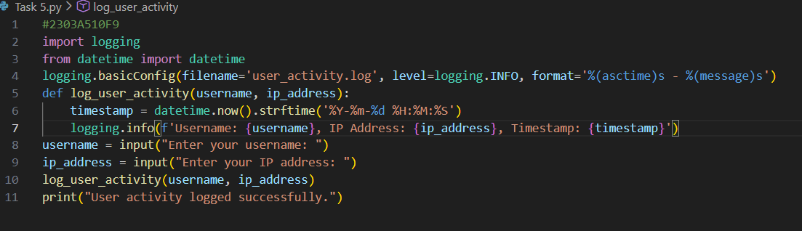
OUTPUT:
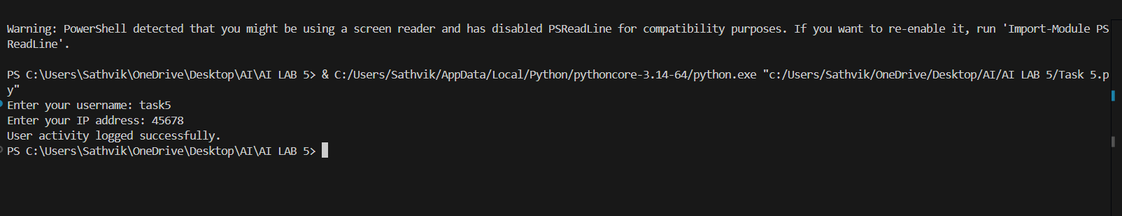
OBSERVATION:
The program logs complete user details such as username and IP address, which may expose sensitive information and create privacy risks if the log file is accessed without proper security.

